1.Подсчитать количество продавцов которые работали с клиентами с самым низким рейтингом

SELECT
`salespeople`.SNAME AS "Имя продавцов",
COUNT(`salespeople`.SNAME) AS 'Количество'
FROM
`orders`,
`customers`,
`salespeople`
WHERE
orders.CNUM = customers.CNUM AND orders.SNUM = salespeople.SNUM AND rating =(
SELECT
MIN(`RATING`)
FROM
`customers`
)
GROUP BY
`salespeople`.`SNAME`

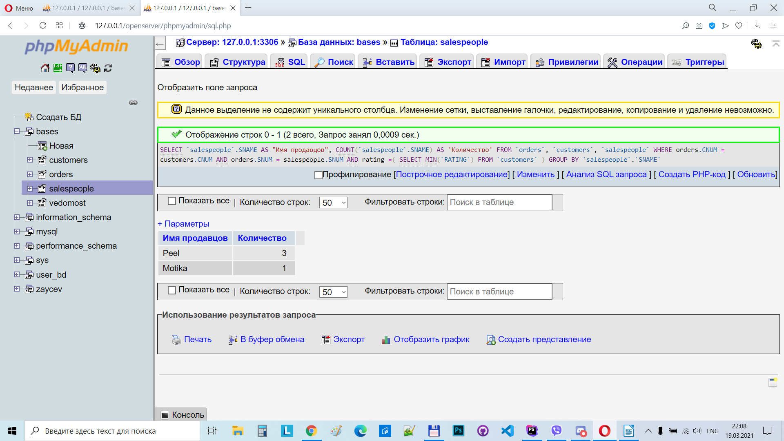
2. Найти продавцов которые обслуживали заказы 10/06/1990

SELECT
salespeople.SNAME,
`orders`.`ODATE`
FROM
`salespeople`,
`orders`
WHERE
salespeople.SNUM = orders.SNUM AND `orders`.`ODATE` IN("1990-06-10")
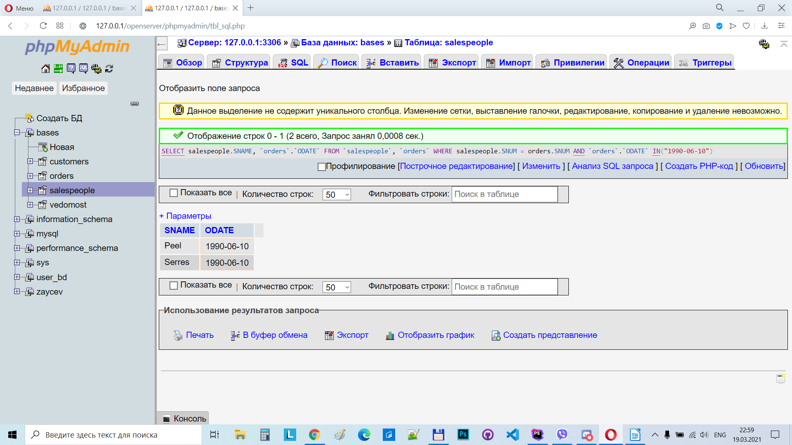
3. Найти города, в которых больше двух клиентов

SELECT
`CITY`,
COUNT(*) AS 'Count customers'
FROM
`customers`
GROUP BY
`CITY`
HAVING
(COUNT(*) >= 2)
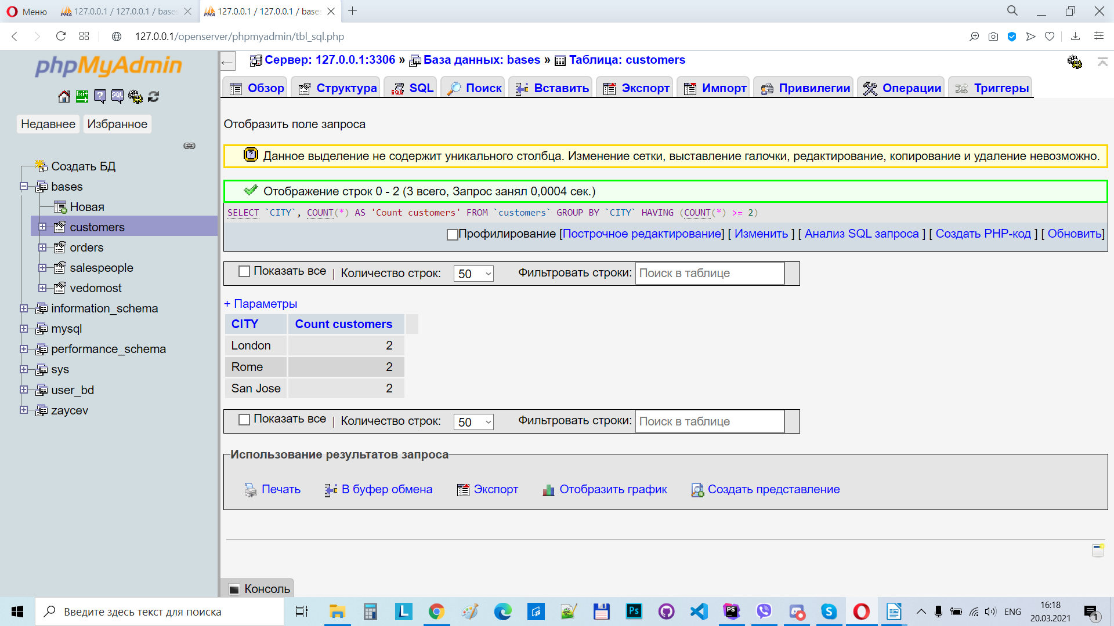
4. Найти города, сумма заказов из которых больше, чем средняя сумма заказов за 10/03/1990

------------------------------------------------------------------------------------------------------------
Cредняя сумма заказов за 10/03/1990
SELECT
AVG(`orders`.`AMT`) AS "AVG"
FROM
`customers`,
`orders`,
`salespeople`
WHERE
`customers`.`CNUM` = `orders`.`CNUM` AND `salespeople`.`SNUM` = `orders`.`SNUM` AND `orders`.`ODATE` IN("1990-03-10")
GROUP BY
`ODATE`

----------------------------------------------------------------------------------------------------------------------
РЕШЕНИЕ

SELECT
`customers`.`CITY`,
SUM(AMT) AS 'SUMM'
FROM
`orders`,
`customers`
WHERE
`orders`.`CNUM` = `customers`.`CNUM`
GROUP BY
`customers`.`CITY`
HAVING
SUM(amt) >(
SELECT
AVG(`orders`.`AMT`) AS "AVG"
FROM
`customers`,
`orders`,
`salespeople`
WHERE
`customers`.`CNUM` = `orders`.`CNUM` AND `salespeople`.`SNUM` = `orders`.`SNUM` AND `orders`.`ODATE` IN("1990-03-10")
GROUP BY
`ODATE`
)

